**Routing and Navigation-**

**What is routing?**

Angular router allows us to switch from one view to another view (page). It allows us to control different routes to different component and flow of data between these components called as “Routing”.

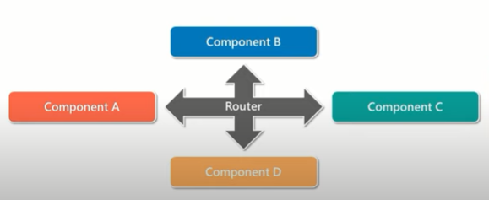

**Example**- Go to Facebook page, first page is login then move from login to home page then home page to send message, etc.

**Why we use routing?**

In traditional web application, when user type the URL in browser, HTTP request is sent to the server, which then retrieve the HTML page. For each new URL, the user is redirected to new HTML page.

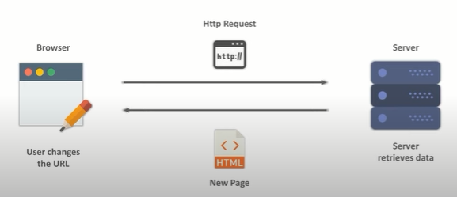

In case of single page application, we don’t load the whole application; we are only loading the part of application. This is done with the help of routers.

Note- before routing we use href tag.

Routes-Define the array of routes, each mapping URL path to component

Router- components navigations

RouterLink- It binds clickable HTML elements to routes.

RouterOutlet- which view is displayed on the particular action.

Component means login, register, about us, contact us page, etc these are components.

Let’s create the three components by using command-

Open terminal

C:\Users\ThisPC\angulardemo> - this is default path

Write the below command

C:\Users\ThisPC\angulardemo>cd src then press enter button

C:\Users\ThisPC\angulardemo\src> then write cd app as per below

C:\Users\ThisPC\angulardemo\src> cd app and press enter button

C:\Users\ThisPC\angulardemo\src\app> then write below command as

C:\Users\ThisPC\angulardemo\src\app> ng generate component login

Open the app-routing.module.ts page

const routes: Routes = [

        {path: 'addUser', component :AddUserComponent},

        {path: 'about', component :AboutComponent},

        {path: 'contact', component :ContactComponent}

];

Then go to app.module.ts page and imports AppRoutingModule as

import { AppRoutingModule } from './app-routing.module';

then import the addUser component, about and contact component as

import { AddUserComponent } from './add-user/add-user.component';

import { AboutComponent } from './about/about.component';

import { ContactComponent } from './contact/contact.component';

go to app.module.ts and declare the components.

@NgModule({

  declarations: [

    AppComponent,

    AddUserComponent,

    AboutComponent,

    ContactComponent

  ],

app.component.html

<h1>Welcome to First Angular Application</h1>

<a routerLink="/adduser">Add User Page </a>|

<a routerLink="/about">About Page details</a>|

<a routerLink="/contact">Contact Page details</a>

<router-outlet></router-outlet>

Then run the program and check the output.

If I enter localhost:4200 and press enter button then nothing will be displayed

**How to set the default page, I mean for example login page.**

Go to app-routing.module.ts and make the below change as

Suppose I want to make the default page as addusercomponent then

  {path: '', component :AddUserComponent},

And go to

<a routerLink="">Add User Page </a>

You can write * or keep ‘ ‘ empty. Routing should be matched.

Note-

Whenever you hit the URL, it will display the addusercomponent page as default.

**Parent child routing**

Now suppose in add user component page, I want to show childpagecomponent

 {path: 'adduser', component :AddUserComponent,

//add child here

        },

Then write like this

  { path: 'adduser', component :AddUserComponent,

        children:[

          { path: 'child', component: ChildrenComponent }

          ]

        },

And add-user.component.html

<p>add-user works!</p>

<a routerLink="child">Child User Page </a>

<router-outlet></router-outlet>

Then try to execute the code, when you click on add user then display the child path link and click on it. child data will be displayed.